**⇒ Mandatory Hands-On**

**Exercise 1: Mocking and Stubbing**

junitdemo/pom.xml

**<project xmlns="http://maven.apache.org/POM/4.0.0" xmlns:xsi="http://www.w3.org/2001/XMLSchema-instance" xsi:schemaLocation="http://maven.apache.org/POM/4.0.0 http://maven.apache.org/xsd/maven-4.0.0.xsd">**

**<modelVersion>4.0.0</modelVersion>**

**<groupId>com.example</groupId>**

**<artifactId>junitdemo</artifactId>**

**<version>default</version>**

**<dependencies>**

**<dependency>**

**<groupId>junit</groupId>**

**<artifactId>junit</artifactId>**

**<version>4.13.2</version>**

**<scope>test</scope>**

**</dependency>**

**<dependency>**

**<groupId>org.mockito</groupId>**

**<artifactId>mockito-core</artifactId>**

**<version>3.12.4</version>**

**<scope>test</scope>**

**</dependency>**

**</dependencies>**

**</project>**

src/main/java/junitdemo/ExternalApi.java

**package junitdemo;**

**public interface ExternalApi {**

**String getData();**

**}**

src/main/java/junitdemo/MyService.java

**package junitdemo;**

**public class MyService {**

**private ExternalApi api;**

**public MyService(ExternalApi api) {**

**this.api = api;**

**}**

**public String fetchData() {**

**return api.getData();**

**}**

**}**

src/test/java/junitdemo/MyServiceTest.java

**package junitdemo;**

**import static org.mockito.Mockito.*;**

**import static org.junit.Assert.*;**

**import org.junit.Test;**

**import org.mockito.Mockito;**

**public class MyServiceTest {**

***@Test***

**public void testExternalApi() {**

**ExternalApi mockApi = Mockito.*mock*(ExternalApi.class);**

***when*(mockApi.getData()).thenReturn("Mock Data");**

**MyService service = new MyService(mockApi);**

**String result = service.fetchData();**

***assertEquals*("Mock Data", result);**

**}**

**}**

**Result:**

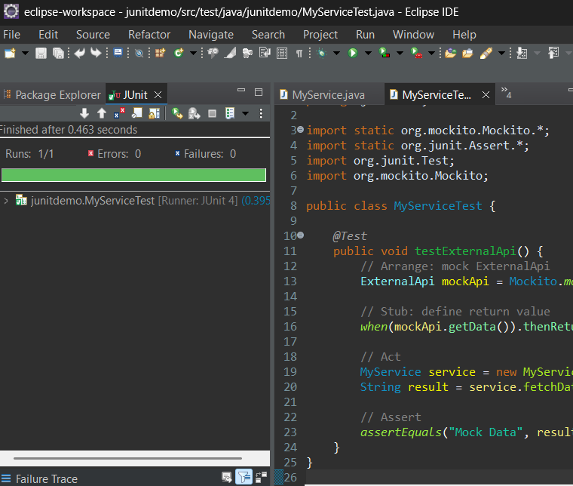

**Exercise 2: Verifying Interactions**

src/test/java/junitdemo/MyServiceTest.java

**package junitdemo;**

**import static org.mockito.Mockito.*;**

**import static org.junit.Assert.*;**

**import org.junit.Test;**

**import org.mockito.Mockito;**

**public class MyServiceTest {**

***@Test***

**public void testExternalApi() {**

**ExternalApi mockApi = Mockito.*mock*(ExternalApi.class);**

***when*(mockApi.getData()).thenReturn("Mock Data");**

**MyService service = new MyService(mockApi);**

**String result = service.fetchData();**

***assertEquals*("Mock Data", result);**

**}**

***@Test***

**public void testVerifyInteraction() {**

**ExternalApi mockApi = Mockito.*mock*(ExternalApi.class);**

**MyService service = new MyService(mockApi);**

**service.fetchData();**

***verify*(mockApi).getData();**

**}**

**}**

**Result:**

